Country Profile One

You are a small, open economy. The basic data of your economy are below. You are wealthy, and you have had a credit-based boom which has turned into a bust. You do not have your own monetary policy. A chart pack will also show you the key variables you need to know about.

The public profiles of the players are as follows.

## Minister for Finance

You are a left-leaning Minister for Finance. You have no prior training in economics and rely on your advisor to interpret the data you are seeing. You are a career politician. You have recently been elected as a government and your government enjoys a large majority thanks to the electoral immolation of the previous incumbent.

The previous government acceded to the conditionality request of the IMF and other international insitutions. You have a target of narrowing the projected deficit by decreasing government spending and increasing taxes in a ratio of 3:1 over the coming 3 years.

You have pledged to re-negotiate the binding agreement your predecessors signed before leaving office.

## Policy advisor

Trained in the USA, you are a career academic only recently brought on as a policy advisor. The Minister relies upon you for much of the analysis they will need to do their job. You will need to counter any of the criticism of their policies domestically, and interact with the international institutions with the Minister.

## Opposition Politician

You are a right-leaning opposition spokesperson. You know the incumbent will seek to blame you for the policies which led to the economic crisis. You are aware you can oppose any changes to the austerity programme or not, and you can choose to be constructive in opposition, or not.

## Media

You are a strong, pro-business media with a large property section. Your finances are in trouble following the collapse in the property market. You are closely aligned with the (now) opposition and consistently worry in prose about the competence of the new administration.

## Unions

You are left-leaning, but weak, as fewer and fewer private sector workers are attracted to your offering. You are aligned with the Minister for Finance’s party and hope they will be able to make the kinds of decisions that will safeguard worker welfare.

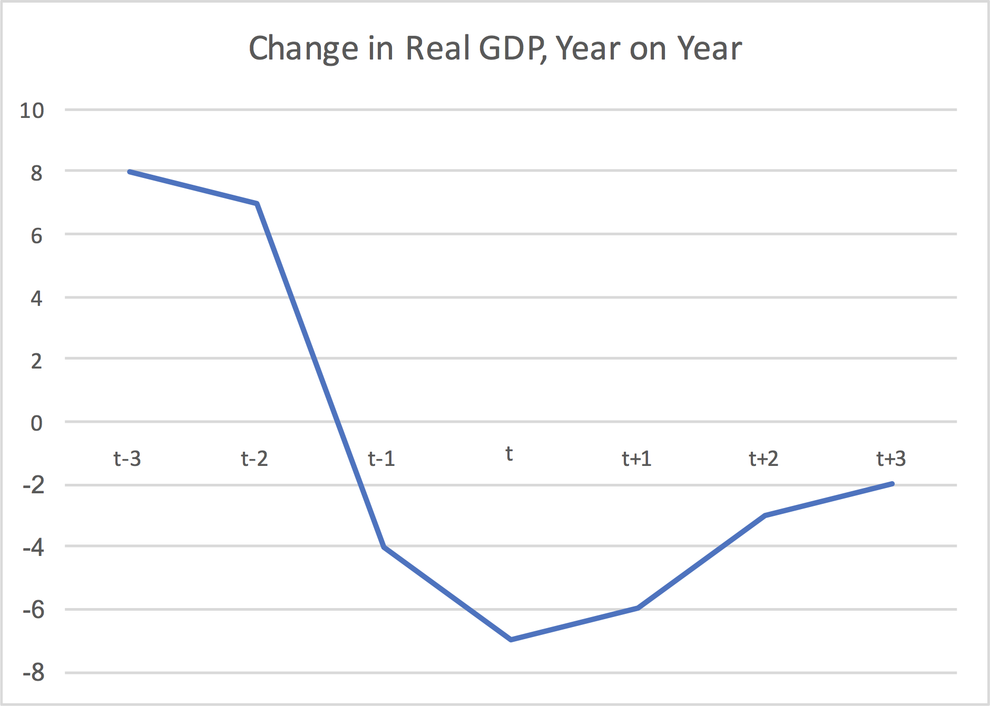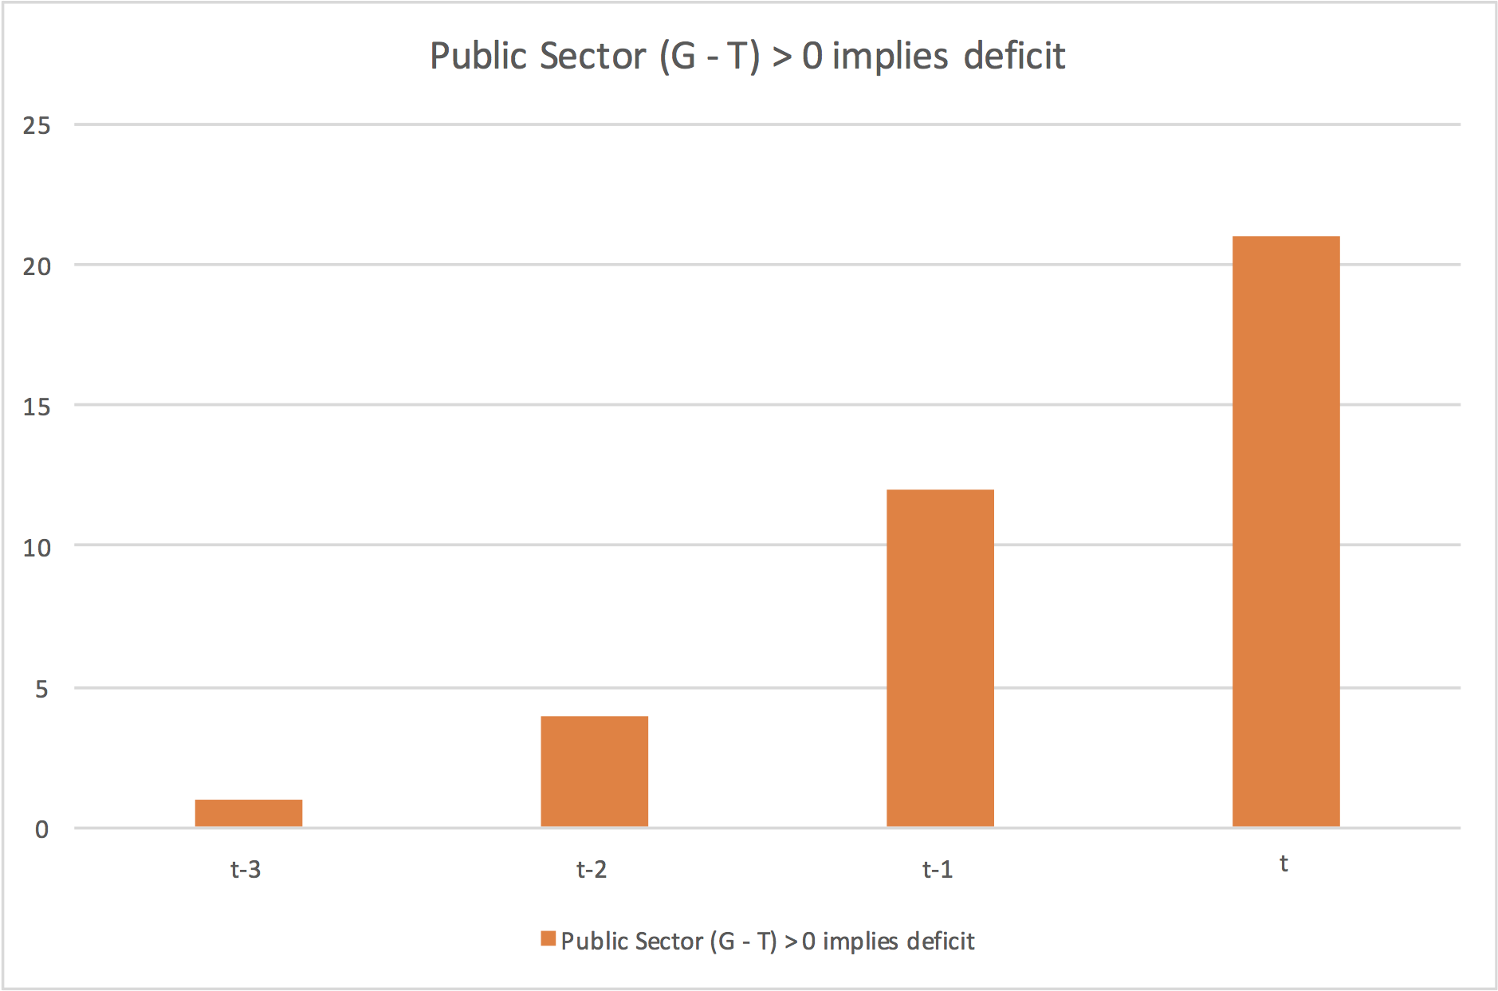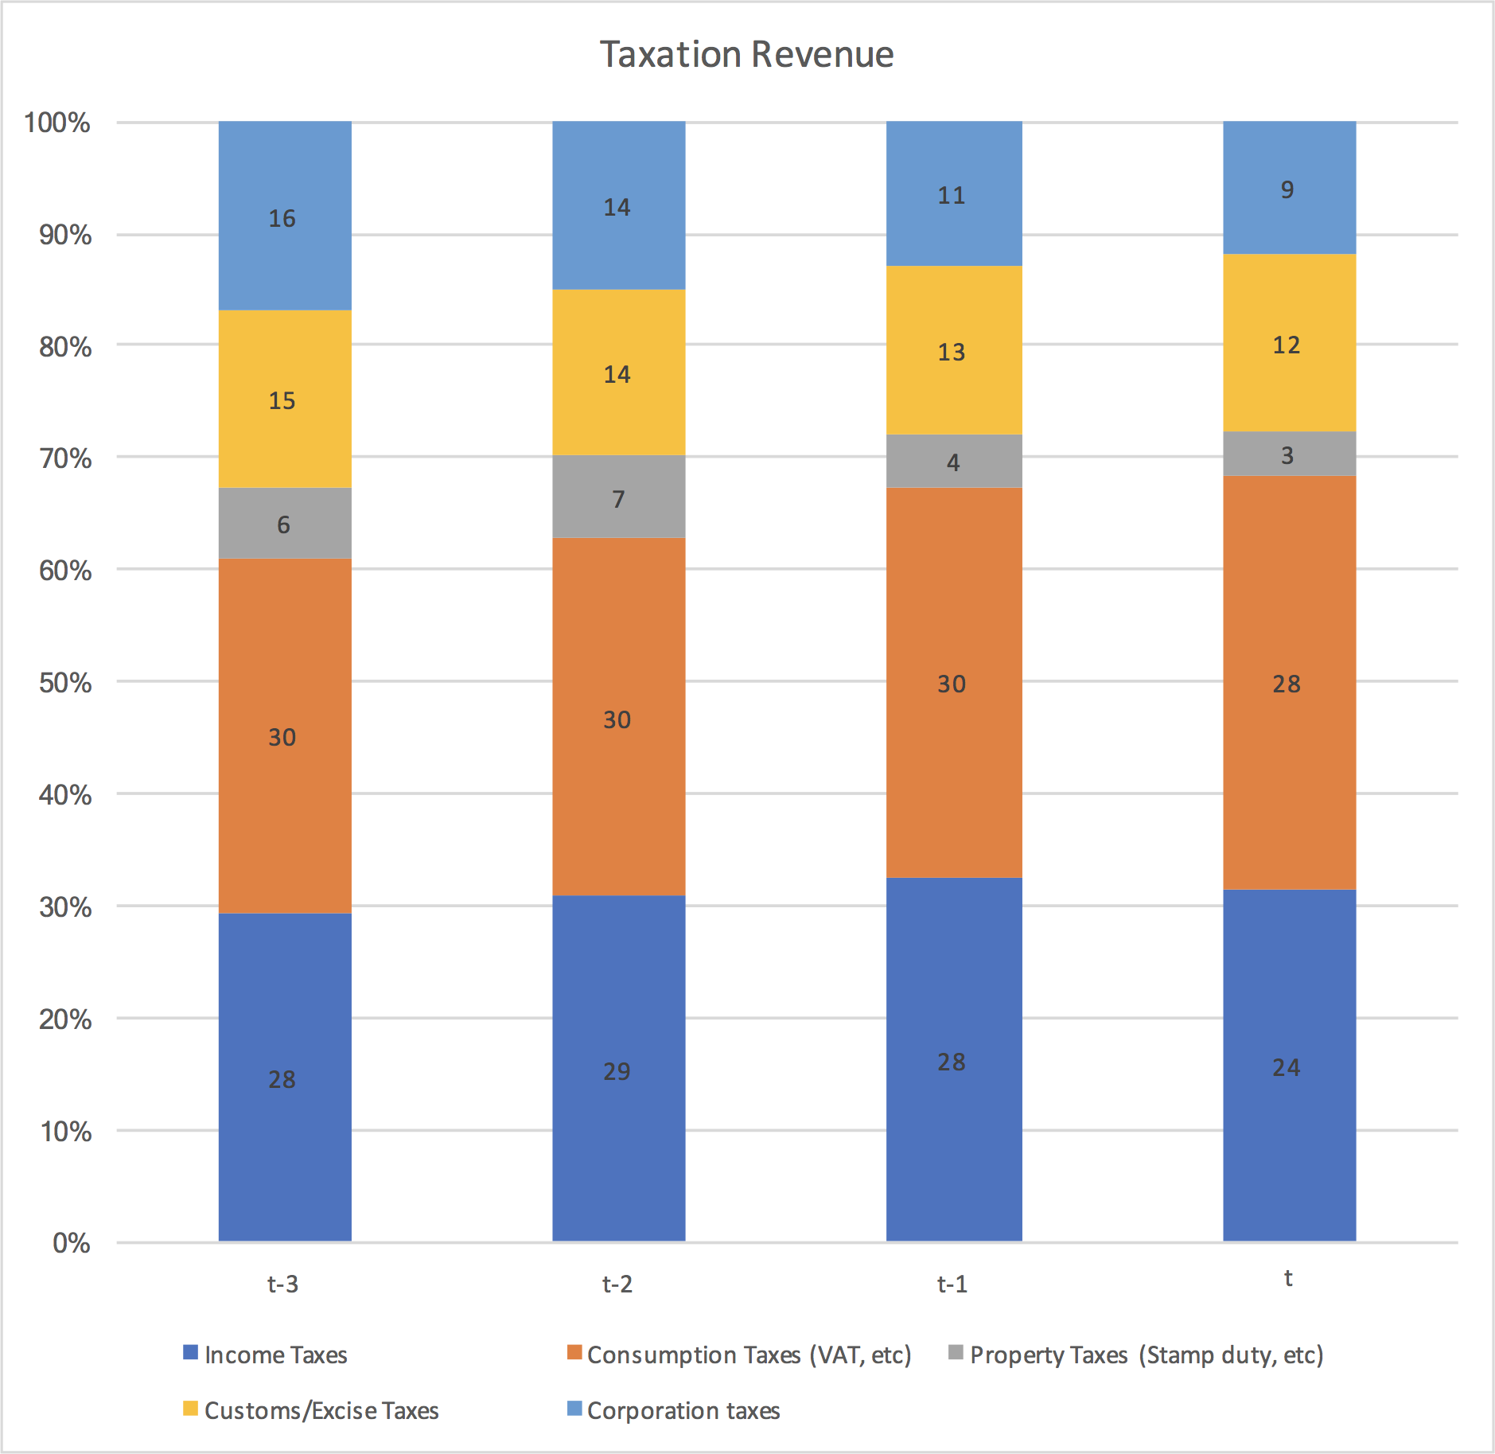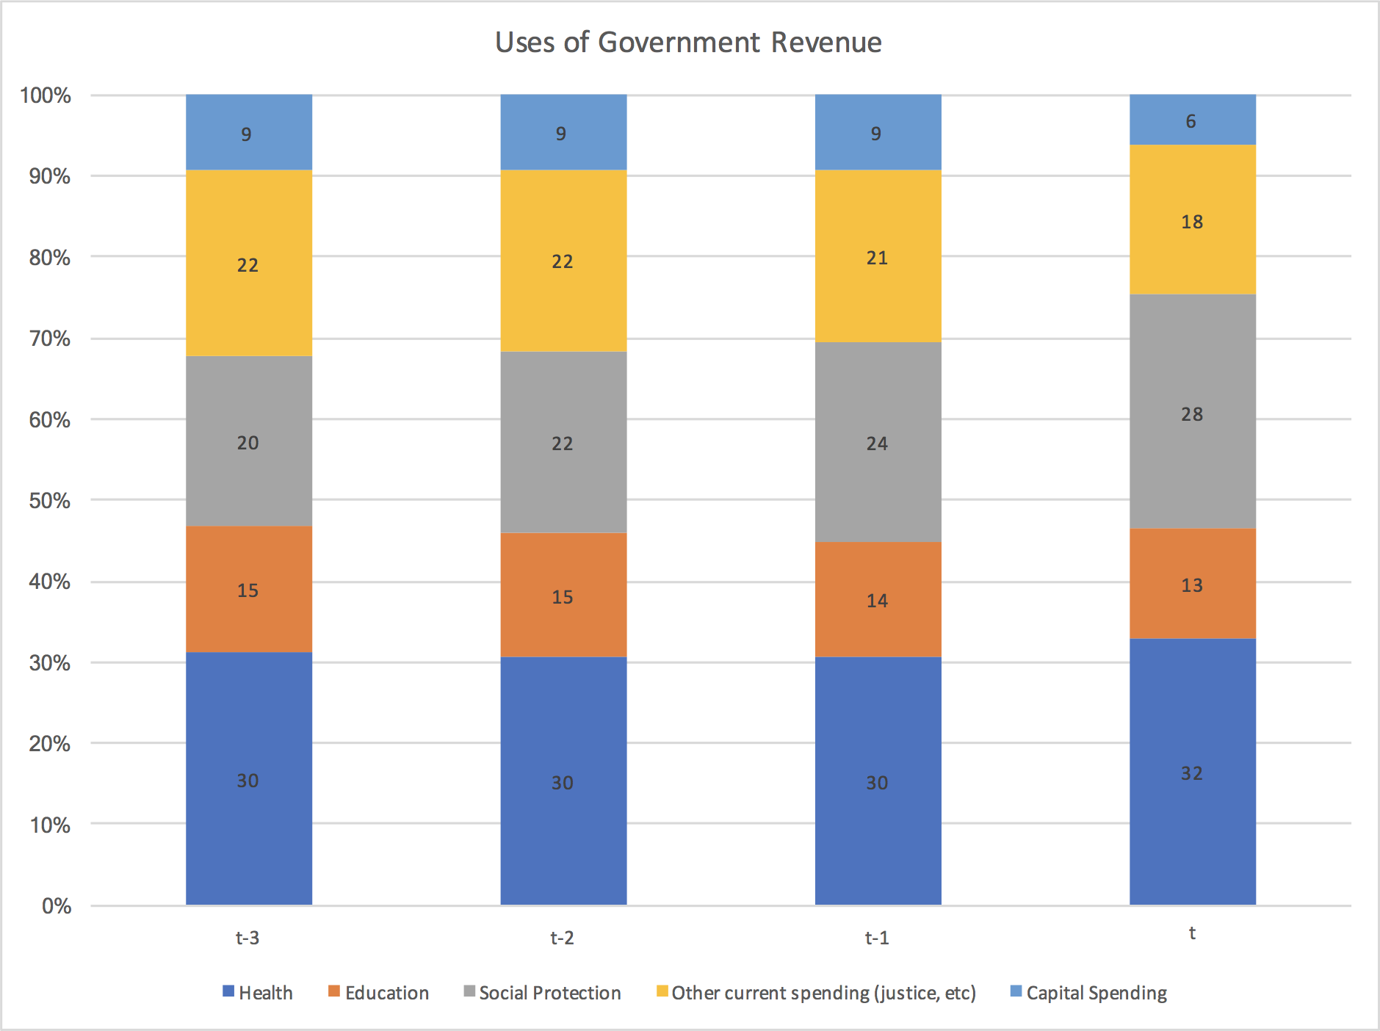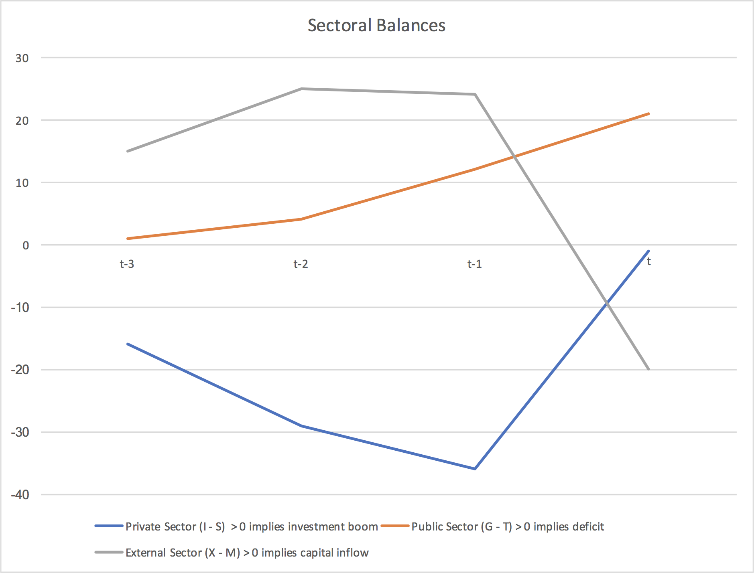

|  |  |  |  |  |  |  |  |  |
| --- | --- | --- | --- | --- | --- | --- | --- | --- |
| Country 1 |  |  | **Past** | **Present** | **3 *t* Forecast (made at time *t*)** | | |  |
| *Major Macro Indicators* | *t-3* | *t-2* | *t-1* | *t* | *t+1* | *t+2* | *t+3* | *t+4* |
| Change in Real GDP, Year on Year | 8 | 7 | -4 | -7 | -6 | -3 | -2 |  |
| Change in Unemployment Year on Year | -3 | -3 | 10 | 15 | 12 | -4 | -5 |  |
| Change in Inflation, Year on Year | 5 | 3 | 1 | -7 | -4 | 3 | 2 |  |
| Change in Government Spending, Year on Year | 5 | 2 | 0 | -1 | -10 | -5 | -5 |  |
| Change in Government Revenue, Year on Year | 8 | -1 | -9 | -12 | -30 | -20 | -10 |  |
| Govt Net Lending/Borrowing | -3 | 3 | 9 | 11 | 20 | 15 | 5 |  |
| Current Account | -15 | -25 | -24 | -20 | -10 | -5 | 5 |  |
| Private Sector net lending (+)/borrowing (-) | -20 | -15 | -20 | 0 | 2 | 5 | 8 |  |
| Debt-Service Ratio, Households | 5 | 5 | 8 | 23 | 23 | 23 | 23 |  |
| Debt-Service Ratio, Firms | 3 | 3 | 14 | 15 | 20 | 40 | 45 |  |
| Non-Performing Loans, International Banks | 3 | 3 | 4 | 4 | 8 | 10 | 20 |  |
| Non-Performing Loans, Domestic Banks | 4 | 4 | 8 | 18 | 20 | 25 | 26 |  |
| Change in Housing completions, year on year | 20 | 30 | 10 | -50 | -20 | 0 | 0 |  |
| Govt Debt Stock, % of GDP | 40 | 42 | 48 | 48 | 52 | 45 | 42 |  |
|  |  |  |  |  |  |  |  |  |
|  |  |  |  |  |  |  |  |  |
| **Fiscal Data** |  |  |  |  |  |  |  |  |
|  |  |  |  |  |  |  |  |  |
| *Government Finances* | *t-3* | *t-2* | *t-1* | *t* | *t+1* | *t+2* | *t+3* | *t+4* |
| Income Taxes | 28 | 29 | 28 | 24 |  |  |  |  |
| Consumption Taxes (VAT, etc) | 30 | 30 | 30 | 28 |  |  |  |  |
| Property Taxes (Stamp duty, etc) | 6 | 7 | 4 | 3 |  |  |  |  |
| Customs/Excise Taxes | 15 | 14 | 13 | 12 |  |  |  |  |
| Corporation taxes | 16 | 14 | 11 | 9 |  |  |  |  |
| **Total (T)** | **95** | **94** | **86** | **76** |  |  |  |  |
|  |  |  |  |  |  |  |  |  |
|  |  |  |  |  |  |  |  |  |
|  | *t-3* | *t-2* | *t-1* | *t* | *t+1* | *t+2* | *t+3* | *t+4* |
| *Government Spending (current)* |  |  |  |  |  |  |  |  |
| Health | 30 | 30 | 30 | 32 |  |  |  |  |
| Education | 15 | 15 | 14 | 13 |  |  |  |  |
| Social Protection | 20 | 22 | 24 | 28 |  |  |  |  |
| Other current spending (justice, etc) | 22 | 22 | 21 | 18 |  |  |  |  |
| Capital Spending | 9 | 9 | 9 | 6 |  |  |  |  |
| ***Total (G)*** | **96** | **98** | **98** | **97** |  |  |  |  |
|  |  |  |  |  |  |  |  |  |
| **Sectoral Balances** |  |  |  |  |  |  |  |  |
|  | *t-3* | *t-2* | *t-1* | *t* | *t+1* | *t+2* | *t+3* | *t+4* |
| Private Sector (I - S) | -14 | -21 | -12 | 1 |  |  |  |  |
| Public Sector (G - T) > 0 implies deficit | 1 | 4 | 12 | 21 |  |  |  |  |
| External Sector (X - M) > 0 implies capital inflow | -15 | -25 | -24 | -20 |  |  |  |  |
|  |  |  |  |  |  |  |  |  |
|  |  |  |  |  |  |  |  |  |
| **Distributional Data** |  |  |  |  |  |  |  |  |
| Income Inequality | 0.61 | 0.65 | 0.66 | 0.59 |  |  |  |  |
| Wealth Inquality | 0.78 | 0.81 | 0.77 | 0.71 |  |  |  |  |
| Health/Morbidity indicator | 97 | 97 | 96 | 92 |  |  |  |  |